TASK 1.1 [2.5 marks]
Write a function in Python that takes a string as input and uses regular expressions to:
- check if the given string is a valid Eircode or not
- if the string is a valid Eircode, identify and print out the Eircode's geographical district.
- Each Eircode consists of seven CAPITAL letters and digits.
- The format of the Eircode is a 3-digit alphanumeric “routing key”, followed by a 4-digit alphanumeric “unique identifier”’.
- The Routing Key will always start with a letter A, C, D, E, F, H, K, N, P, R, T, V, W, X or Y, and will be followed by two numeric digits (0-9) – except for the area of the D6W where the letter W is valid on the 3rd digit.
- The Unique Identifier will comprise a mixture of letters and/or numbers – letters A, C, D, E, F, H, K, N, P, R, T, V, W, X or Y, and numbers 0-9.

- An optional space or hyphen could separate the Routing Key from the Unique Identifier, for example, “V94 T9PX”, “V94-T9PX”

- You can download the full list of routing keys in CSV format from HERE using the !wget command.
- Use the 're' library for regular expressions in Python.
- Regex101 is a handy website for trying and testing your regular expressions.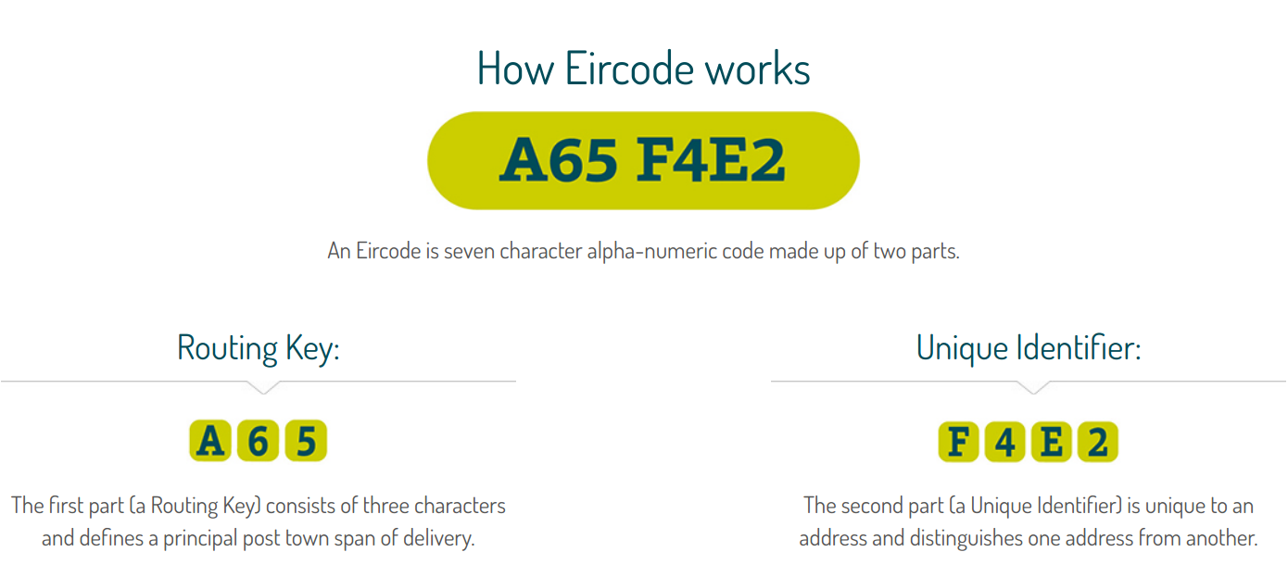
import re # import re library for regex
import csv # import csv library to handle the Eircode CSV file

# use the linux command wget to donwload the CSV file
!wget https://gist.githubusercontent.com/ajoorabchi/eac194a79dd26de8864f9206b7842ff1/raw/8ea1d8d5f74b5b2724e378b43d4df6094990c7db/Eircode%2520Routing%2520Key%2520Boundaries.csv
filePath = "/content/Eircode Routing Key Boundaries.csv" # set the path for the donwloaded CSV file

with open(filePath, 'r') as f:
reader = csv.reader(f)
KeyRouteList = list(map(tuple, reader)) #the map function iterates through the rows in the CSV file and puts them in tuples. The tuples are then added to the KeyRouteList [(k0,d0), ...,(kx,dx)]
print(KeyRouteList)

def eircodeValidator(eircode):
YOUR CODE HERE

# Your eircodeValidator function should be able to handle the test cases below:
eircodeValidator("D6W-19PX")
eircodeValidator("V94-T9PX")
eircodeValidator("A91 T9PX")
eircodeValidator(" A93T9PX ")

eircodeValidator("D6Z-T9PX")
eircodeValidator("123-T9PX")

eircodeValidator("V94 -T9PX")
eircodeValidator("V94,T9PX")

eircodeValidator("v94 T9px")

eircodeValidator("V94T9PXV")
eircodeValidator("V94T9P")

Expected Output:
Your eircodeValidator function should be able to handle all the supplied test cases.
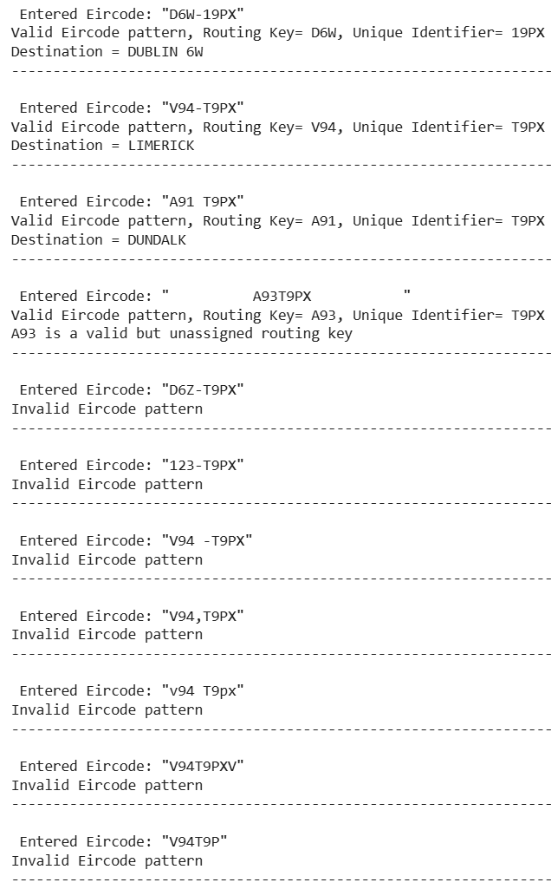

Task 1.2 [2.5 marks]

Complete the contactsExtractor function in the code snippet below. The function should try to extract as many UL-specific contacts (i.e., UL phone numbers, UL email addresses, and UL URLs) from the contact information page of the UL website as possible.

Hint 1: the re.findall() method iterates over a string to find a subset of characters that match a specified pattern. It will return a list of every pattern match that occurs in a given string.

import re # import re library for regex
!pip install html2text
import html2text # import html2text library to convert and extract the text content of the HTML file

!wget https://www.ul.ie/contact-information # Use the Linux command wget to download the webpage
filePath = "/content/contact-information" # Set the path for the downloaded HTML file
contact_information_file = open(filePath, "r")
contact_information_html = contact_information_file.read()
contact_information_text = html2text.html2text(contact_information_html)
#print(contact_information_text) #uncomment to see the text content of the page

def contactsExtractor(contact_information_text):
YOUR CODE HERE

contactsExtractor(contact_information_text)

Expected Output:
n Phone Numbers found: ['0035361202700', …]
n E-mails found: ['reception@ul.ie', …]
n URLs found: ['www.ul.ie/library', …]
, where n is the total number of matches found.

- Try to reduce the number of Type I (false-positive) and Type II (false-negative) errors as much as possible.
- Evaluate the performance of your Information Extraction function in terms of the number of Type I and Type II errors.

Task 2.1
Use the !wget command to download the Complete Works of William Shakespeare from here; then open the downloaded text file and print out its first 50 lines.

Python String splitlines() Method Split a string into a list where each line is a list item.
#TASK 2.1
from tensorflow.keras.preprocessing.text import Tokenizer
!wget http://www.gutenberg.org/files/100/100-0.txt
filePath = "/content/100-0.txt"
ShakespeareFile = open(filePath, "r")
ShakespeareContent = ShakespeareFile.read()
ShakespeareContent = ShakespeareContent.splitlines() # The splitlines() method splits a string into a list. The splitting is done at line breaks.
print(f'list of first 50 lines: {ShakespeareContent[0:50]}')
YOUR CODE HERE

Task 2.2 [2 marks]
Use the tf.keras.preprocessing.text.Tokenizer class to:
- Tokenize the Shakespeare corpus
- Print out the total number of Tokens in the corpus
- print out the total number of Types in the corpus
- Print out the top 10 most frequent Types in the corpus along with their ranks and frequencies. For example:
"the" is ranked #1, with a frequency of xxxxx
.
.
.
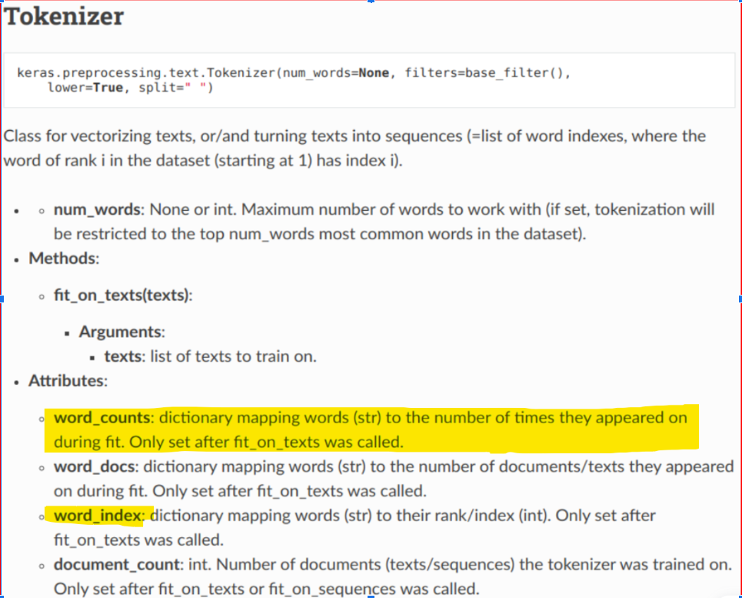

Task 2.3 [2 marks]
Use the nltk.stem.porter.PorterStemmer and nltk.stem.WordNetLemmatizer classes to:
- stem all the Types in the Shakespeare corpus, and print out the total number of Types after stemming.
- Lemmatize all the Types in the Shakespeare corpus, and print out the total number of Types in the corpus after lemmatization.
- Confirm the validity of this arithmetic expression:
total_number_of_types > total_number_of_lemmatized_types > total_number_of_stemmed_types
#TASK 2.3
from nltk.stem import PorterStemmer
import nltk
nltk.download('wordnet')
from nltk.stem.wordnet import WordNetLemmatizer
ps = PorterStemmer()
lemmatizer = WordNetLemmatizer()
YOUR CODE HERE

Task 2.4 [1 mark]
Use the Sentence Segmentation module in the spaCy package to:
- Segment the last 20 lines of the Shakespeare corpus into sentences
- print out the segmented sentences and their total number.

HINT: 20 lines in a text file is just that, 20 lines; think of it as 20 lines on a sheet of paper; how many sentences are on that sheet? No way to know until you read and count. One sentence could occupy just half a line, whereas another sentence could occupy multiple lines. lines on a sheet of paper are physical concepts, whereas sentences are grammatical concepts; distinguishing the difference between the two is the goal of this exercise.

</END OF E-TIVITY>

Resources for Data Science and Statistical Learning students:
- A gentle introduction to OOP in Python (classes, methods, attributes, objects)

Teaching team
- Addition of BPE
- Level of difficulty (easy/fair/hard)
- TF tokenizer vs.NLTK tokenizer
- String Fundamentals, Concatenation, Indexing and Slicing: Python Basics
- Text to Word cloud
- Demo Zipf's law in the Shakespeare corpus - plot 1st 100 top freq words.
- 1.2 and 1.5 as main vs. complementary
- More restricted Eircode pattern + Eircode finder verification
- POS effect of lemmatization

